The Class of 1986 News Journal
News and Announcements from the Lobo Class of ’86 Family (Via Facebook mostly!)

August 2014
The Lobo Class of ’86 Class Reunion Survey
In case you’ve been living under a rock during the summer like I have, here’s the announcement of the survey along with its link- A listing of the survey questions is on page 2 .
Greetings Classmates,
WHERE has the time gone? It's been almost 5 years since our last reunion and it's time to start planning our 30th class reunion. If you think you would like to host our 30th reunion then by all means let me know or if you have a suggestion then please e-mail: eastexaslobos1986@yahoo.com. If no one wants to take on the planning of the reunion, I will assume the responsibility.
In the mean time, I would like to hear what YOU think about a reunion cruise. There is a brief survey located at http://www.classcreator.com/Longview-TX-1986/class_index.cfm
This survey is intended to gather as much input from you on how to best serve your needs and make our 30th reunion better. All answers are confidential and only a tally of responses will be shared with other members. Please visit the survey page, login and fill out the survey. Thank you for your valuable time and help.
Regards,
LaTrenna Coss
1) | * Are you interested in cruising for the 25th class reunion?   Yes No

2) | * If not, what other ideas/options would you prefer?

3) | * What month do you prefer to cruise?
  June
  July
  August
  September
  Other

4) | * Preferred Cruise Line (Departure City should be considered before selecting)

5) | * How many days do you prefer to cruise?

6) | * Spouses and significant others are welcome. Should we also extend the invitation to.

7) | * Are you interested in reserving space onboard the vessel if possible for a WHS meet & greet?  Yes No

8) | * Do you and/or your significant other have a US. Passport?  Yes No

9) | * Your thoughts, suggestions or ideas (Please Specify)

These are the questions found in the survey in the official Lobo Class of ’86 A Class To Remember Website- Be sure to go to the website and take the survey if you’re a classmate and if you haven’t already-!

From Ye Editor (which is me, Cedric E.)
I apologize for not having a newsletter out for July- my summer classes at SFA had me very, very busy and I just wasn’t able to find the time to get it finished. This week (August 10) is the first week I haven’t had to worry about homework, quizzes, computer programs, exams, etc., but now, I go back to work (LHS) Friday. Where did the summer go?
Hope you all enjoy this picture-filled newsletter (what one does when one has no news and/or is too lazy/tired to do much else- LOL)

Inside This Issue
1 | From Ye Editor
2 | A Listing of the Survey Questions
3 | Pictures, Pictures, Pictures!
4 | Check out these links






















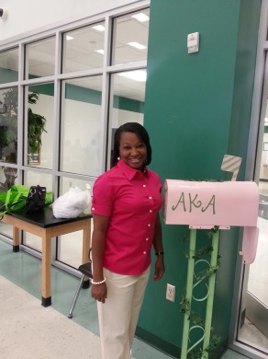






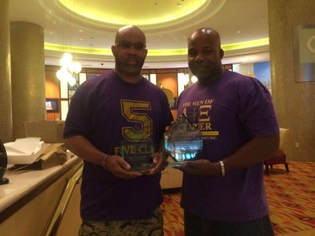

PICTURES! PICTURES! PICTURES!

Check out these links:

The Lobo Class of 1986 Webpage
THE BEST CLASS EVER!


http://www.acedwardslobos86.com/LOBO86/Class86.html

Cedric E. Tales of the House Rocker Blog


http://cedric-e.blogspot.com/

LONGVIEW HIGH SCHOOL – 1986
A CLASS TO REMEMBER!


http://www.classcreator.com/Longview-TX-1986/class_index.cfm

From the Pictures section, starting from top-left:
Lee Warren and son, Roy Craine, James and Rosalyn Cantue, Choyce Gray (HAPPY BIRTHDAY- AUGUST 12! Couldn’t resist!), Amanda Miles, Marcus Williams looking dapper as usual, Kevin Wyatt, Donnie Childs, Daryl Gregg, Tammy Allen and Terry Lilly, Kirt Villyard and friends, Frank Weedon and family, David Garrett, Sarah Herring and Angie Clark, Wray Wade (the Man!), Jennifer Anderson-Barnes, Deborah Pryor-Fuller and Tammy Allen, Tim King, Tunga Tatum-Hicks, and Tracy George.

